**What is Advocacy?**

* **Definition:** Advocacy is an effort to promote political or social change by raising public awareness and support for specific causes or policies.

**Why is Advocacy Necessary?**

* **Protect Self-Interest:**
  + Employment, Wages, and Benefits: Ensures fair labor practices and better working conditions.
  + Self-Expression, Dress Codes: Supports individuals' rights to express themselves freely.
* **Educate and Provide Public Awareness:**
  + Disease Prevention, Smoking termination: Raises awareness about health risks and promotes healthier lifestyles.
  + Civic Awareness, Voting Registration: Encourages voter participation and strengthens democracy.
* **Promote a cause via public/private events:**
  + Breast cancer awareness
  + HIV/AIDS prevention

**Types of Advocacy**

* **Instructed Advocacy:** Advocates act on behalf of individuals who can express their wishes.
* **Non-instructed Advocacy:** Advocates act on behalf of individuals who cannot express their wishes.
* **Non-statutory Advocacy:** Advocacy that is not required by law but is provided to support individuals.
* **Self-advocacy:** Individuals represent and speak up for themselves.

**Principles of Advocacy**

* **Clarity of Purpose:** Have clear understanding of the advocacy goals.
* **Evidence-Based:** Use factual and reliable information.
* **Inclusivity:** Ensure all voices are heard.
* **Accountability:** Be responsible for actions and decisions.
* **Persistence:** Continuously working towards the goal.
* **Respect for Diversity:** Value different perspectives and backgrounds.
* **Ethical Practice:** Maintain integrity and honesty.
* **Collaboration:** Work with others to achieve common goals.
* **Adaptability:** Be flexible and open to ideas.

**Who Makes the Most Effective Advocate?**

* **Personal Connection:** Those who share a personal connection with the issue.
* **Potential Impact:** Those who could be impacted by the issue.
* **Desire to Make a Difference:** Anyone who wants to make a positive change.

**Process of Advocacy as a Tool**

1. **Identify Issue:** Recognize the problem that needs addressing.
2. **Collect Data:** Gather relevant information and evidence.
3. **Set Goals:** Define clear and achievable objectives.
4. **Develop Strategy:** Plan the approach to achieve the goals.
5. **Build Alliances:** Form partnerships with like-minded individuals and organizations.
6. **Raise Awareness:** Inform and educate the public about the issue.
7. **Engage Decision-Makers:** Communicate with those in power to influence change.
8. **Implement Actions:** Carry out the planned activities.
9. **Monitor:** Track progress and make necessary adjustments.
10. **Follow Up:** Ensure continued support and evaluate the impact.

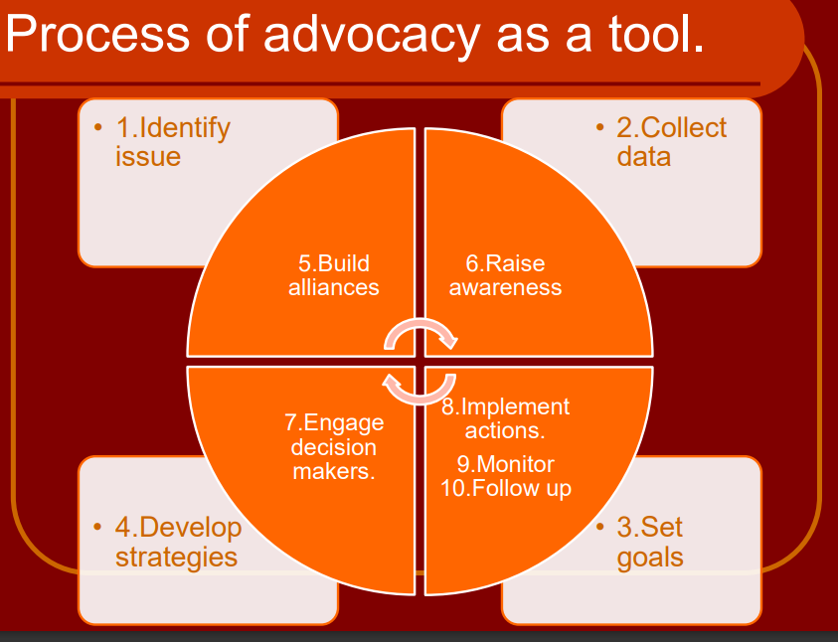

**How to Develop an Advocacy Strategy**

An approach aimed at getting someone in power, typically government or corporate, to do something in the public interest that they wouldn’t otherwise do.

**Examples:**

* + Restore funding to the education budget.
  + Reduce manufacturing waste emissions.

**Determining Your Issue**

**You must** analyze the problem and decide what kind of solution is obtainable; this could be either short or long term.

**You must** frame the issue in a way that will gain the most support; practice positive spin.

**Obtain credible information from:** The internet, library, and news outlets.

**Obtain public perceptions from:** Commentary on social networking sites, blogs, and editorials.

**Establish Your Goal**

Without a clear, obtainable goal your advocacy will lack purpose, direction, and the intended outcome.

* **Long-term:** A long-term goal is one you eventually hope to obtain and usually has many factors to address.
* **Short-term:** A short-term goal has a more immediate resolution and may be one step in advancing a longer-termed goal.

**Effective Issues**

* Are easy to understand
* Have a clear target
* Are non-divisive
* Result in meaningful life improvements
* Instil a sense of power to the powerless
* Are broadly and deeply felt
* Are winnable

**Identifying Your Targets**

* **Key Players:** Determine which individuals, political figures, community leaders, religious, civic and trade organizations would have an interest, to advance or protect, that is related to your issue; these would be natural allies or constituents
* **Opposition:** Research and understand those against your issue.

**Messaging & Tactics**

* **Messaging:** Messaging or “talking points” outline your issue, its current impact, and your recommended resolution.
* **Messengers:** Messengers are the individuals or organizations that will publicly carry the message to identified targets.
* **Tactics:** Tactics are the short-term activities used to positively influence targets to produce the intended resolution.

**Messaging Should Be**

* **Easy to understand:** Plain English, accurate and factual, reliable sources.
* **Consistent:** Among all messengers, tailored to the interest of your intended target.
* **Concise and to the point:** Makes it easy to remember and repeat.

**Targets Should Include**

* **Elected officials:** Federal, state, and local government.
* **Organizations:** Religious, civic, Greek, public and private.
* **Media outlets:** Television, radio, print, internet.
* **Anyone who’ll listen:** Friends, family, teammates, co-workers.

**Tactics May Include**

* **Face-to-face meetings:** Appointments with officials, rallies, town hall meetings.
* **Internet:** Emails, blogs, social media.
* **Phone calls**
* **Writing** letters, postcards, petitions, editorials.
* **Media coverage**

**Evaluation & Follow-up**

It is critical that you review responses received from your targets in order evaluate the effectiveness of your messaging and tactics.

It is also important to provide post-advocacy follow-up with messengers and allies

**Evaluation Should Ask**

* **Effectiveness:** Were messaging and tactics effective?
* **Explanation:** Were you able to explain the issue in simple terms?
* **Counterarguments:** Were you able to provide factual counterarguments?
* **Follow-up:** Were unanswered questions investigated and followed up promptly?
* **Visibility:** Did tactics provide consistent and impactful visibility?
* **Responses:** What responses were received? Were they supportive or confrontational?
* **Strategy:** Could a change in strategy produce more positive results?
* **Resolution:** Did messaging and tactics produce the intended resolution?
* **Supporters:** Were opponents persuaded, and allies empowered? Were networks of future supporters established?

**Post-advocacy Follow-up Should Include**

* Thank you letters, emails, and phone calls
* **Debriefing with participants:** Discuss successes and failures for future reference.
* **Establishment of new networks:** Legislative and advocacy supporters.
* **Platform:** Keeps you and your supporters connected to the issue and future developments.